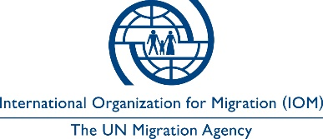

Open to Internal and External Candidates
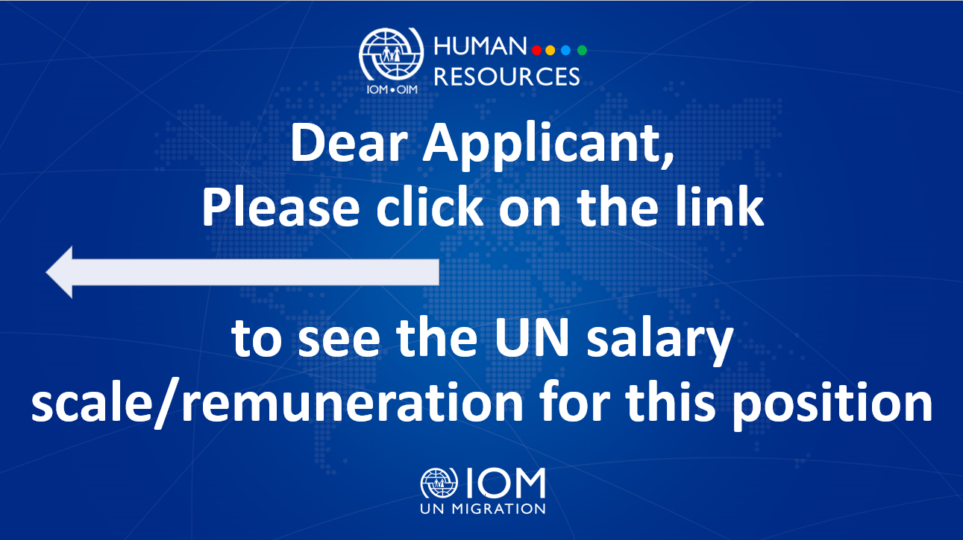

Position Title | : | Senior Security Assistant
Duty Station | : | Odesa, Ukraine
Classification | : | General Service, Grade 6
Type of Appointment | : | Fixed-Term, One Year with  possibility of extension
Estimated Start Date | : | As soon as possible
Closing Date | : | 05 March 2024

Established in 1951, IOM is a Related Organization of the United Nations, and as the leading UN agency in the field of migration, works closely with governmental, intergovernmental and non-governmental partners. IOM is dedicated to promoting humane and orderly migration for the benefit of all. It does so by providing services and advice to governments and migrants.

IOM is committed to a diverse and inclusive environment. Internal and external candidates are eligible to apply to this vacancy. For the purpose of the vacancy, internal candidates are considered as first-tier candidates.

Context:

Under the overall supervision of EUBAM Head of Mission and IOM Ukraine Chief of Mission, and under the direct managerial supervision of the National Security Officer (NSO) based in EUBAM HQ in Odesa, with the administrative supervision of EUBAM Chief of Administration (CoA), the successful candidate will be responsible for providing specialized support to enable IOM’s activities and assist the National Security Officer with all aspects of security risk management.
The incumbent will support the National Security Officer in establishing and maintaining an appropriate level of security awareness throughout HQ and UA Field Offices within EUBAM.

Core Functions / Responsibilities:

- Support the National Security Officer (NSO) in all aspects of security risk management that will effectively address issues that could have an impact on the security of EUBAM personnel, premises, assets, and operational activities in EUBAM HQ and UA Field Offices.
- Provide assistance in collaboration, coordination and establishment of networks with other international organizations, government security services and agencies working in the security management field, ensure appropriate lines of communications relating to all aspects of staff safety and security related to EUBAM are established and well maintained.
- In coordination with the National Security Officer, deliver security learning/training activities, briefings and ensure that these activities are carried out professionally and within UNSMS training standards.
- Provide assistance in maintaining the EUBAM’s Emergency / Contingency Plans (such as operations and medical evacuation, Business Continuity Plan (BCP), and emergency communications systems).
- Support to conduct facilities and operational safety/security threats assessments/evaluations and provide recommendations. Assist in providing relevant technical analysis on potential threats/risks and ensure that appropriate safety/security information is disseminated to personnel.
- Maintain updated security staff lists, including the list of Security Focal Points, Alternative Security Focal Points, and Wardens (Deputy Wardens). Review staff movements' tracking system and accommodation security procedures.
- Assist the National Security Officer in ensuring that all relevant safety and security information is disseminated in a timely manner to EUBAM personnel. Provide general administrative assistance to the NSO.
- Assist in ensuring timely reporting to the local and/or national authorities, UNDSS and IOM SSU on security incidents.
- Monitor the physical security of EUBAM premises and keep track of all security equipment. Ensure that all safety and security communications equipment is functioning and in good condition with a regular inventory duly maintained.
- Monitor the activities and operations of EUBAM Security Guards. Conduct annual performance appraisal exercise for them (EUBAM service contract holders, non-IOM staff).
- Assist in ensuring residential and office safety preparedness. Conduct security surveys of residences and Mission premises, recommend appropriate arrangements to secure them, and ensure good state of all security equipment.
- Perform such other duties as may be assigned.

Required Qualifications and Experience

Education
- University degree in Security, Social Sciences, International Studies, Communications or a related field from an accredited academic institution with four years of professional experience.
OR
- Completed High School degree from an accredited academic institution with six years of relevant professional experience.

Experience
- Work experience in security management systems, law enforcement and military disciplines;
- Experience with the UN Security Management System (UNSMS) or Humanitarian security field is an advantage;
- Experience in providing security training to personnel is desirable;
- Experience in dealing with law enforcement agencies;
- Experience in liaising with security networks and counterparts in the region is an advantage.

Skills

- Excellent communication skills, both oral and written;
- Valid driving licence, ability to drive 4x4 vehicles with manual transmission;
- Knowledgeable in Microsoft applications (Word, Excel, PowerPoint and Teams) is required;
- Political and social knowledge of the region;
- Ability to work in a multi-cultural environment with a team of diverse professional backgrounds is required.
- Ability to handle a heavy workload efficiently with minimal supervision and understanding the importance of close teamwork is highly regarded.

Languages

For all applicants, fluency in English and Ukrainian is required (oral and written).

Competencies

The incumbent is expected to demonstrate the following values and competencies:

Values
- Inclusion and respect for diversity: respects and promotes individual and cultural differences; encourages diversity and inclusion wherever possible.
- Integrity and transparency: maintains high ethical standards and acts in a manner consistent with organizational principles/rules and standards of conduct.
- Professionalism: demonstrates ability to work in a composed, competent and committed manner and exercises careful judgment in meeting day-to-day challenges.
- Courage: Demonstrates willingness to take a stand on issues of importance.
- Empathy: Shows compassion for others, makes people feel safe, respected and fairly treated.

Core Competencies – behavioural indicators - level 2
- Teamwork: develops and promotes effective collaboration within and across units to achieve shared goals and optimize results.
- Delivering results: produces and delivers quality results in a service-oriented and timely manner; is action oriented and committed to achieving agreed outcomes.
- Managing and sharing knowledge: continuously seeks to learn, share knowledge and innovate.
- Accountability: takes ownership for achieving the Organization’s priorities and assumes responsibility for own action and delegated work.
- Communication: encourages and contributes to clear and open communication; explains complex matters in an informative, inspiring and motivational way.

Other

Any offer made to the candidate in relation to this vacancy notice is subject to funding confirmation.

Appointment will be subject to certification that the candidate is medically fit for appointment and security clearances.

A prerequisite for taking up the position is legal residency in the country of the duty station and work permit, as applicable.

How to apply:

Interested candidates are invited to submit their applications using the IOM Personal History Form and sending to vacancies_ukraine@eubam.org by 05 March 2024 the latest, referring to this advertisement in the subject line of your message.

Only shortlisted candidates will be contacted.

Posting period:
From 21.02.2024 to 05.03.2024

